CMSC203 Assignment 6 Implementation (Documentation)

Class: : CMSC203 CRN 30295
Program: Assignment 6
Instructor: Gregoriy Grinberg
Summary of Description: (Give a brief description for each Program)
Due Date: 05/04/2026
Integrity Pledge: I pledge that I have completed the programming assignment independently.
I have not copied the code from a student or any source.
Student:

Part 1: UML Class Diagram:
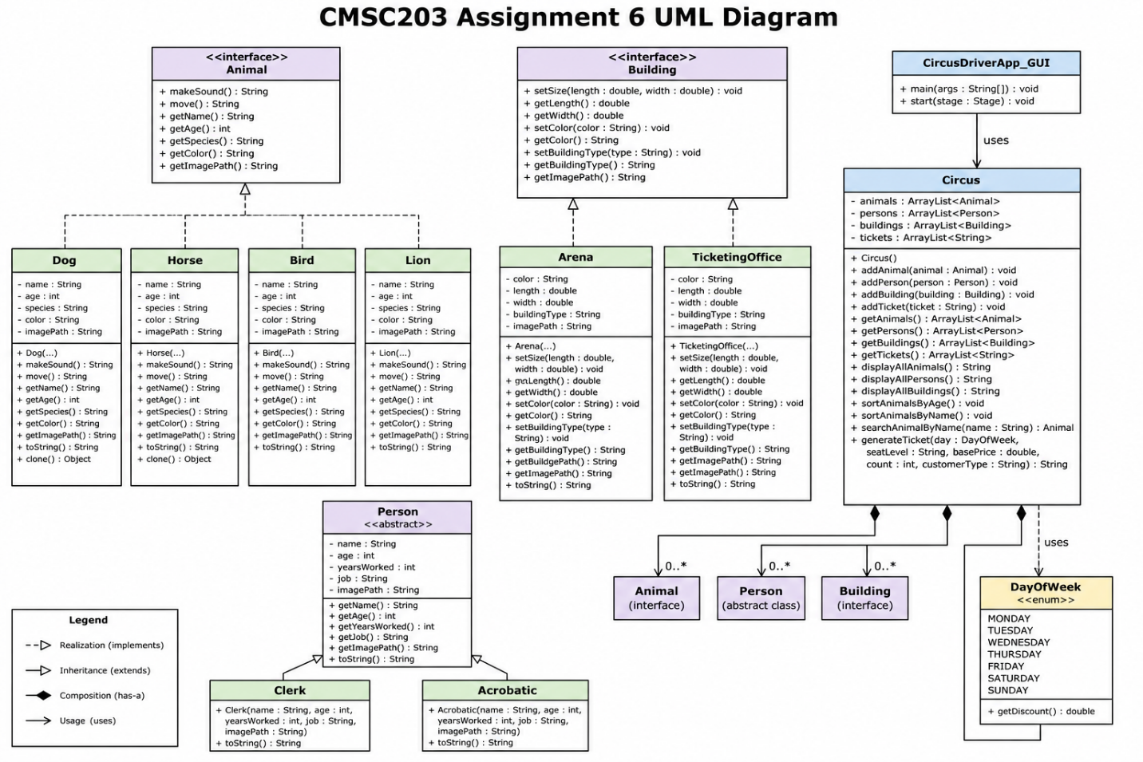
Part 2: Comprehensive Test Plan

Cases | Input | Expected Output | Actual Output | Did the test pass?
Case 1 | Added 4 animals, then clicked Display All Animals. Animals entered: Dog anderson ayala, age 15; Bird Rio, age 2; Lion Leo, age 6; Horse Leo, age 3. | Program should display all animals with their name, age, species, and color. | Program displayed all 4 animals in the output area and in the image/details panel. | y
Case 2 | Clicked Sort Animals by Age, then clicked Sort Animals by Name. | Program should sort animals correctly by age and by alphabetical name order. | After Sort Animals by Age, the order shown was Rio, Leo (Horse), Leo (Lion), anderson ayala (Dog). After Sort Animals by Name, the order shown was anderson ayala, Leo (Horse), Leo (Lion), Rio. | y
Case 3 | Clicked Search Animal by Name. Searched one valid name and one invalid name. | For a valid name, the program should display the matching animal. For an invalid name, the program should display Animal not found. | Valid search returned Found: Horse [Name: Leo, Age: 3, Species: horsenare, Color: brown]. Invalid search returned Animal not found. | y
Case 4 | Clicked Generate Ticket. Entered Monday, Lower Level, base price $42.00, ticket count 42, then finished ticket entry. | Program should apply weekday discount, seat level pricing, and show the final ticket calculation details. It should also prompt Do you want to add more tickets? (y/n): | Program displayed: Day: Monday, Seat Level: Lower Level, Base Price: $42.00, Price Per Ticket: $51.03, Ticket Count: 42, Total Price: $2143.26, and showed the Do you want to add more tickets? (y/n): prompt. | y

Part 3: Screenshots:
        - Screenshots of running the CircusDriverApp_GUI.java (like screenshots in the Assignment Description).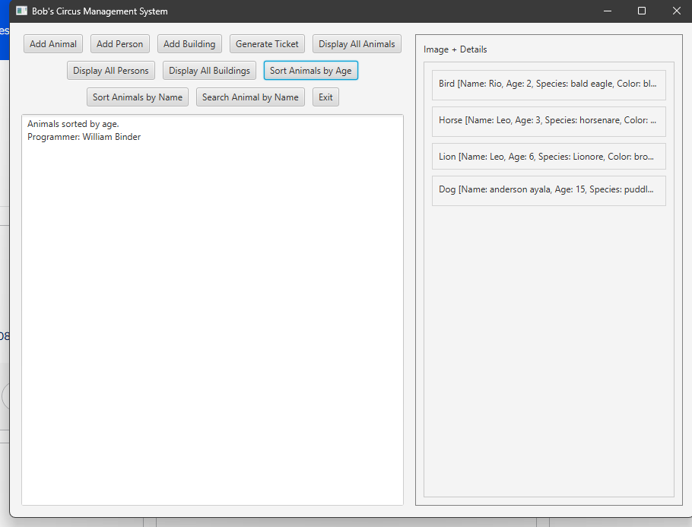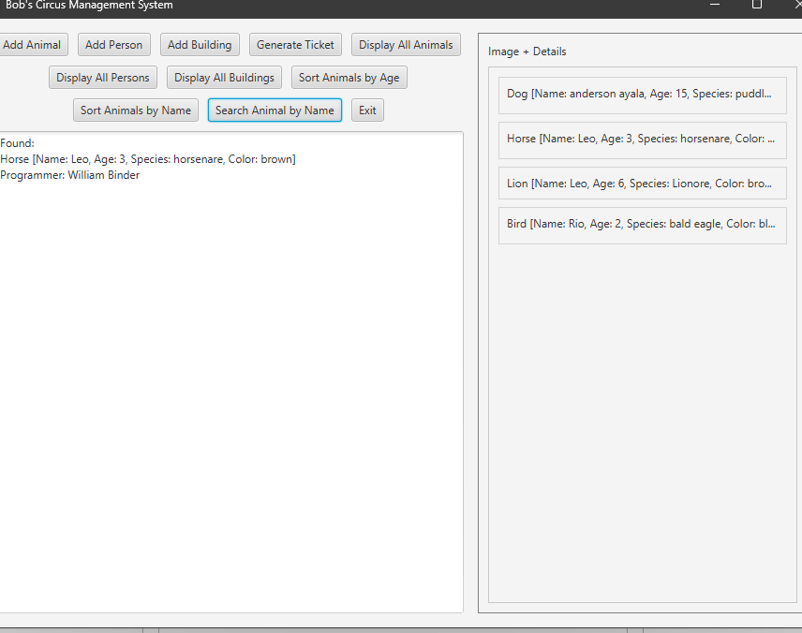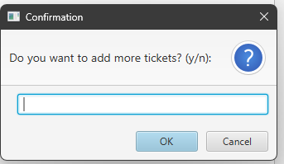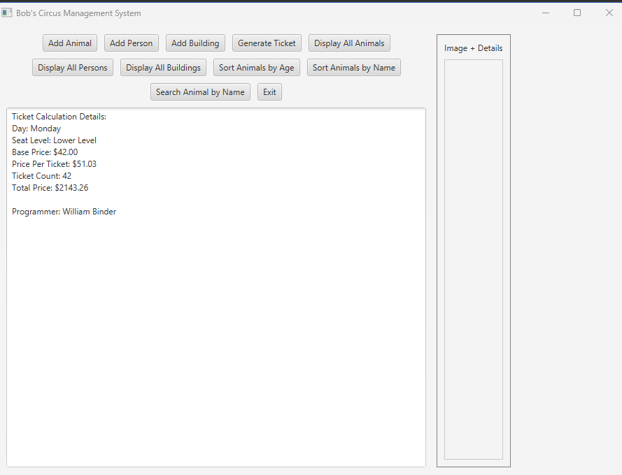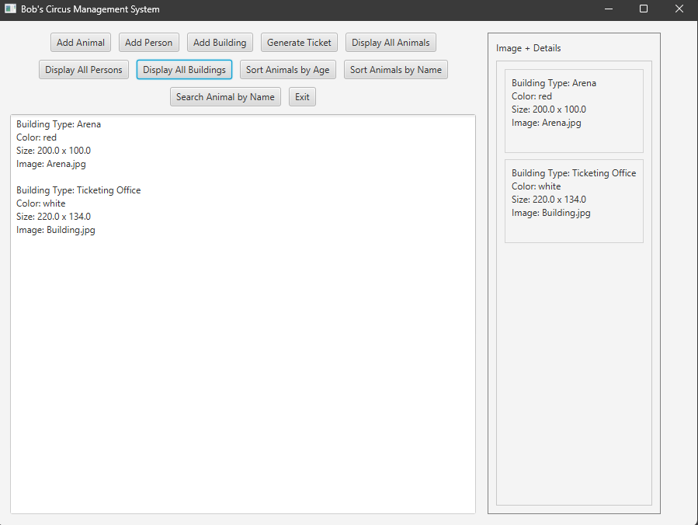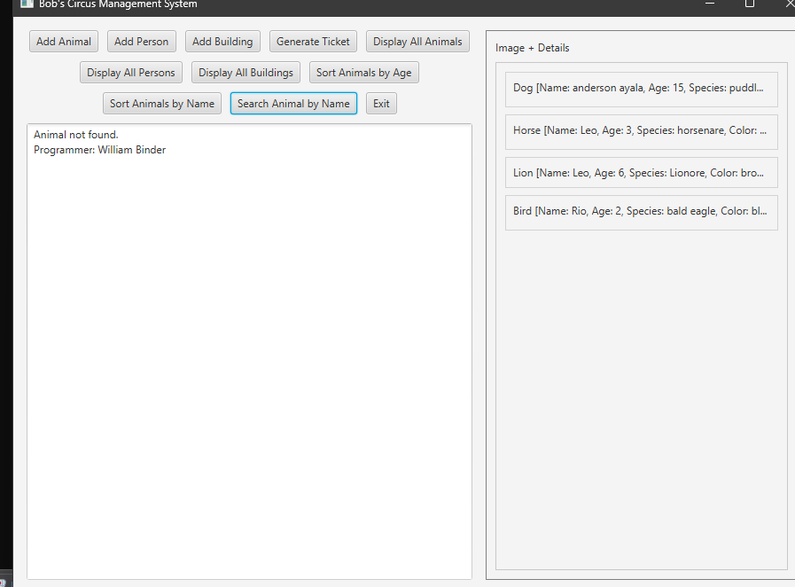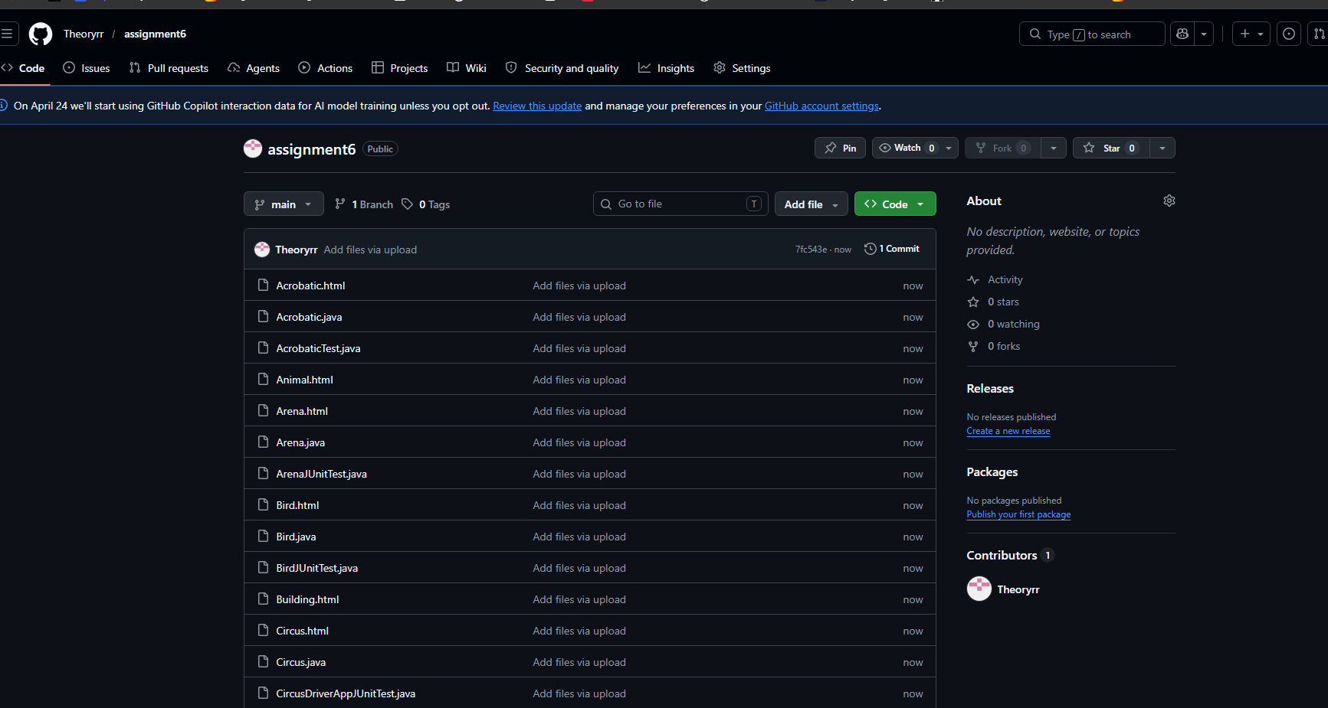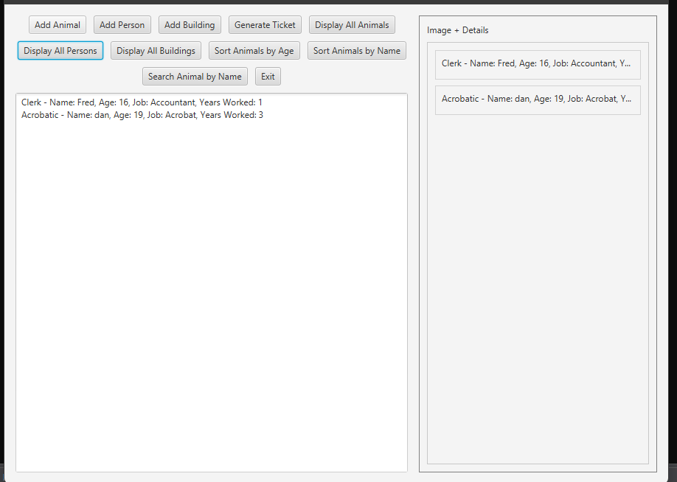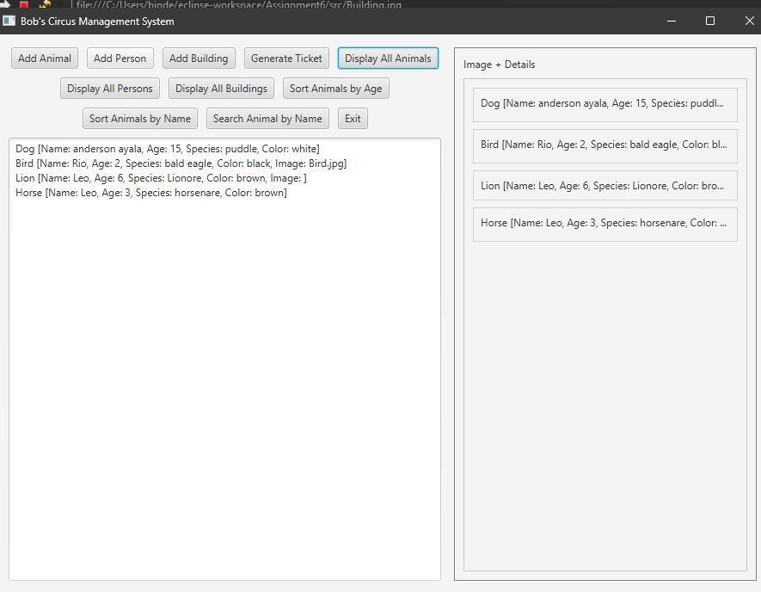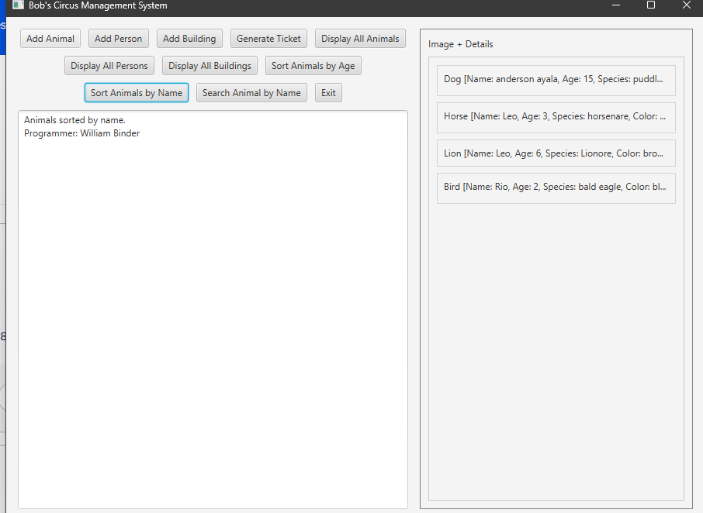

        - Screenshots of all Junit Tests with extended tests for each method
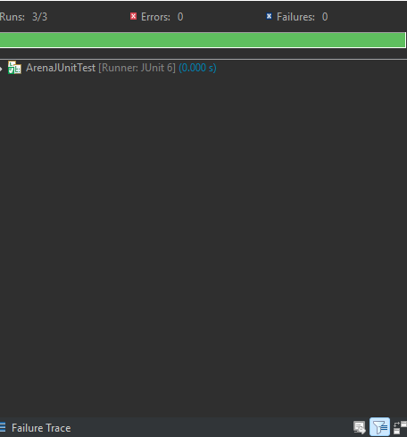
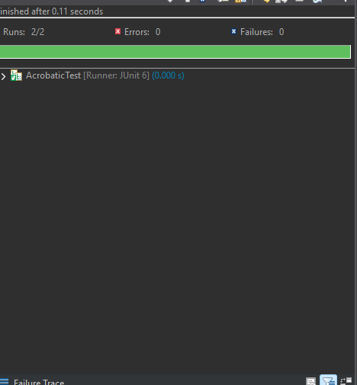

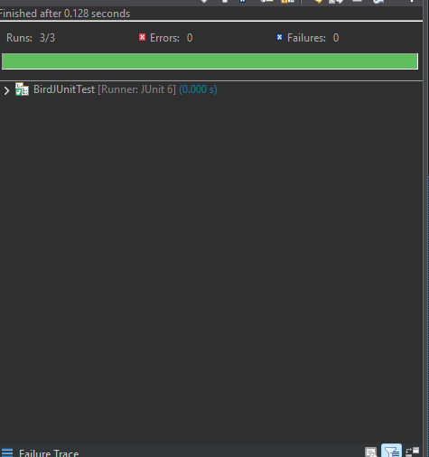
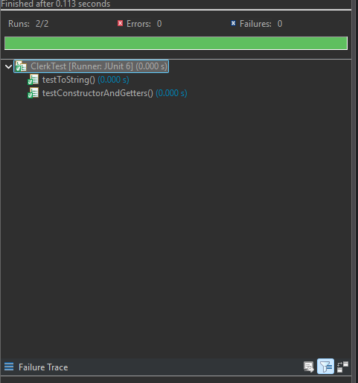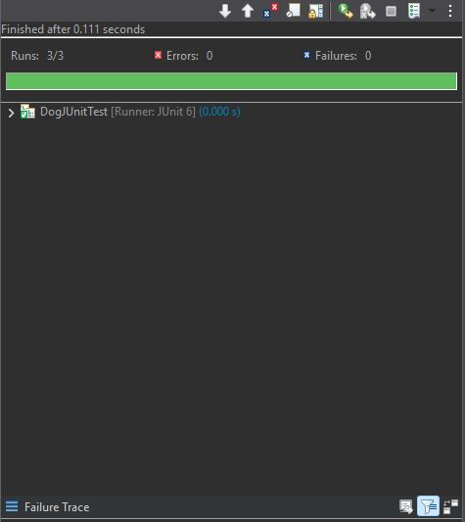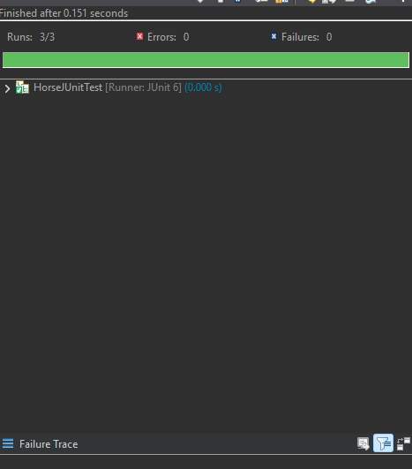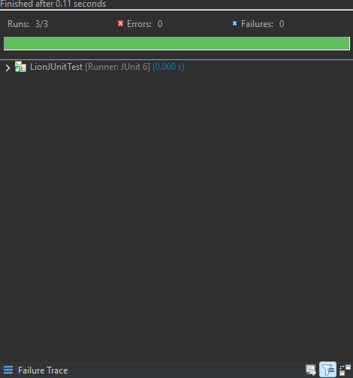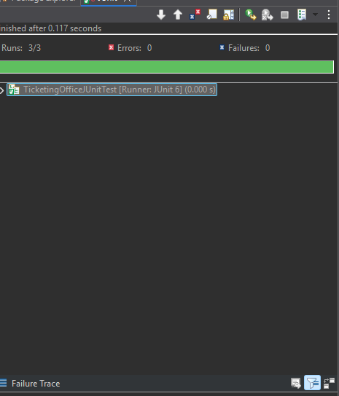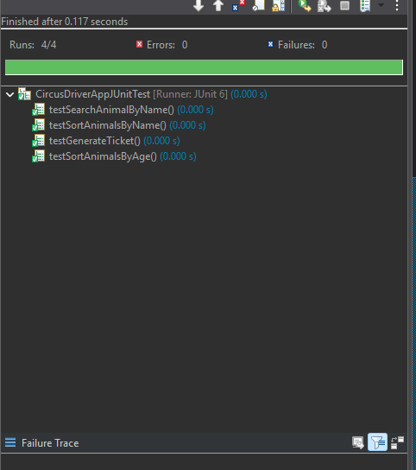
        - Screenshot of the src folder files in your GitHub repository

Lessons Learned <Provide answers to the questions listed above>:

Write about your Learning Experience, highlighting your lessons learned and the learning experience from working on this project.
This project helped me better understand how object-oriented programming works in a full program. I got more practice using interfaces, abstract classes, inheritance, polymorphism, ArrayLists, sorting, searching, exception handling, and JavaFX. It was a good learning experience because I had to connect many topics together instead of using them one at a time. I also learned how important testing is, because even when the program looked mostly correct, JUnit tests helped me find problems like clone method issues and setup mistakes.

What have you learned?

I learned how to build a larger Java program with multiple classes that work together. I learned how interfaces and abstract classes help organize code, how ArrayLists can store different objects, how to sort and search data, and how to create a GUI with JavaFX. I also learned more about setting up JUnit and JavaFX correctly in Eclipse.

What did you struggle with?
I struggled the most with setting up the project environment, especially JavaFX VM arguments, JUnit version issues, and fixing compile errors caused by placeholders and duplicate files. I also had to be careful about matching the rubric, adding documentation comments, and making sure every class and test file was included.

What would you do differently on your next project?
I struggled the most with setting up the project environment, especially JavaFX VM arguments, JUnit version issues, and fixing compile errors caused by placeholders and duplicate files. I also had to be careful about matching the rubric, adding documentation comments, and making sure every class and test file was included.

What parts of this assignment were you successful with, and what parts (if any) were you not successful with? I was successful with building the required classes, getting the GUI to run, implementing sorting, searching, ticket generation, and passing the JUnit tests. I was also successful with creating the screenshots and documentation after the program was working. The hardest part for me was the setup and debugging stage, especially JavaFX, JUnit, and clone methods, but I was able to fix those problems by testing and revising the code.

Provide any additional resources/links/videos you used to while working on this assignment/project.

Check List: <Provide answers to the column Y/N >:

# |  | Y/N | Comments
 | Assignment files:
 | - FirstInitialLastName_ Assignment6_JavaFiles.zip
 | - FirstInitialLastName_ Assignment6_Complete.zip
 | - FirstInitialLastName_Assignment6.docx/.pdf
 | - Source Java files
 | The Program compiles
 | The program runs with the desired outputs related to a Test Plan
 | Documentation file:
 | - Comprehensive Test Plan
 | - Screenshots of running the CircusDriverApp_GUI.java
 | - Screenshots of all Junit Tests with extended tests for each method
 | - Screenshots of your GitHub account with submitted Assignment 6
 | - UML Diagram (if required)
 | - Lessons Learned
 | - Checklist is completed and included in the Documentation

